# Team 24 – Sprint 1 Testing Document

Sakshi Choudhary, Giorgi Khmaladze, Nick Litman, Mihir Somani, Conley Utz

User Story #6

**Test 1.1: Given that the user have not filled out all required fields in the listing, if they attempt to post their listing, then the listing is not added to the database and they are prompted to fill the remaining required fields**

Purpose: To meet acceptance criteria that improperly formatted listings are not added to the database

Steps:

1. User does not enter any required information

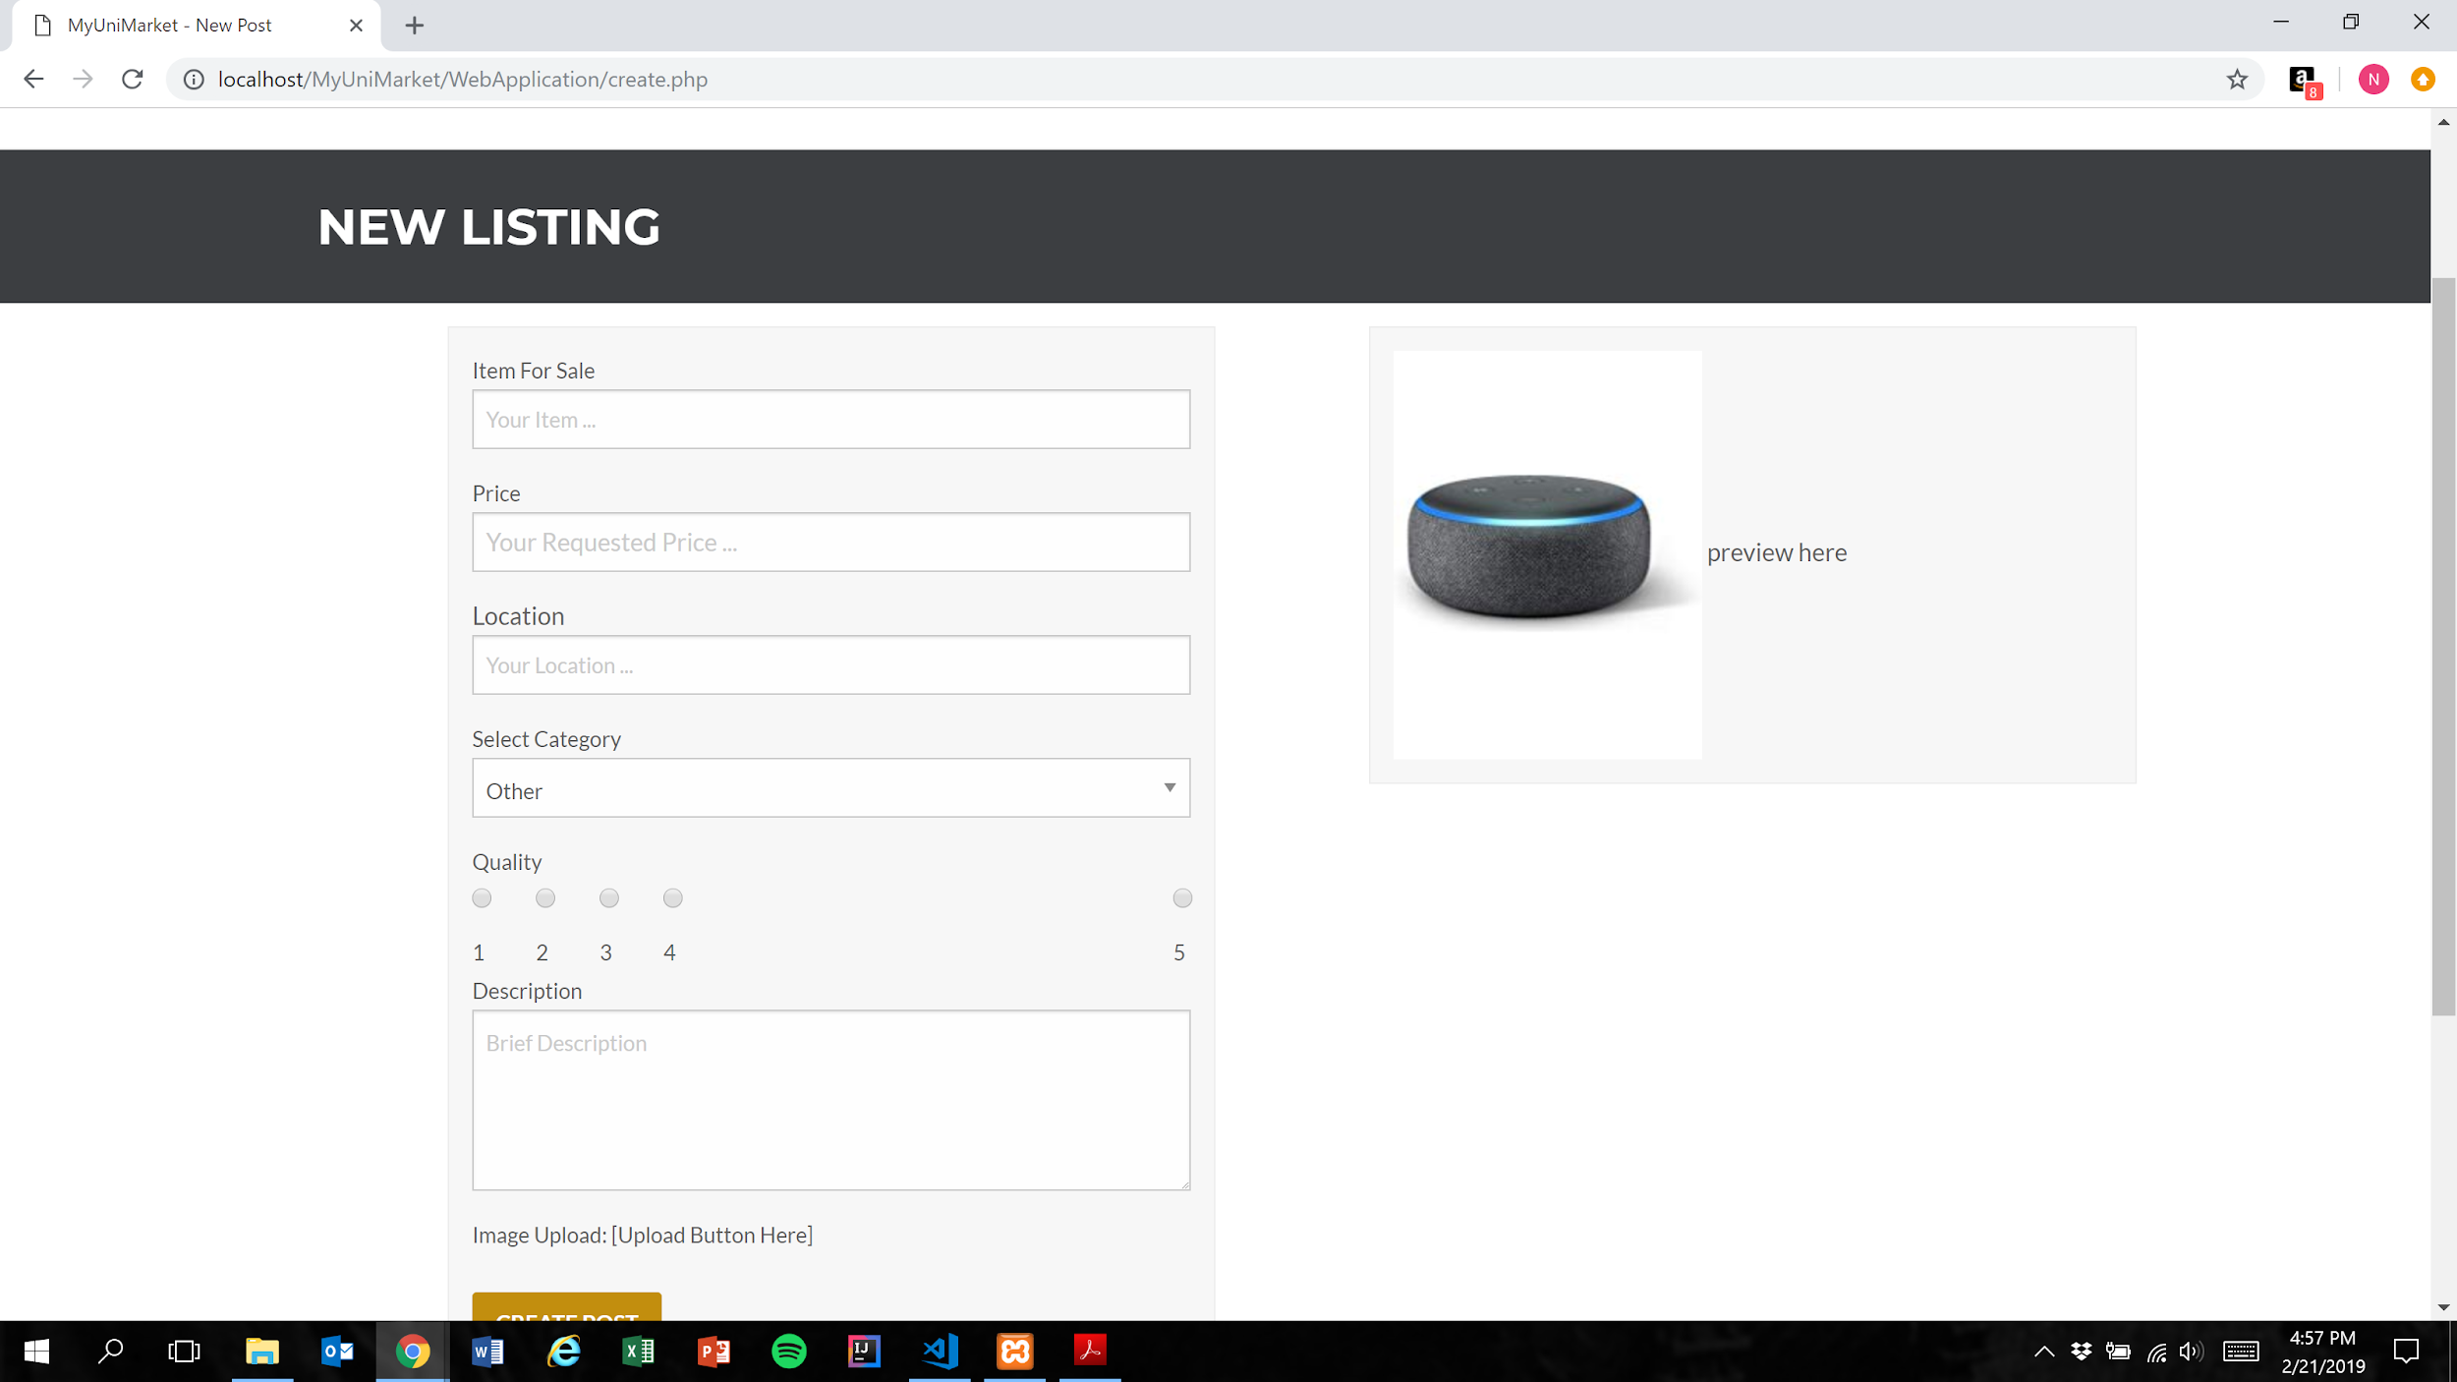

2. User presses the create post button

Figure 1

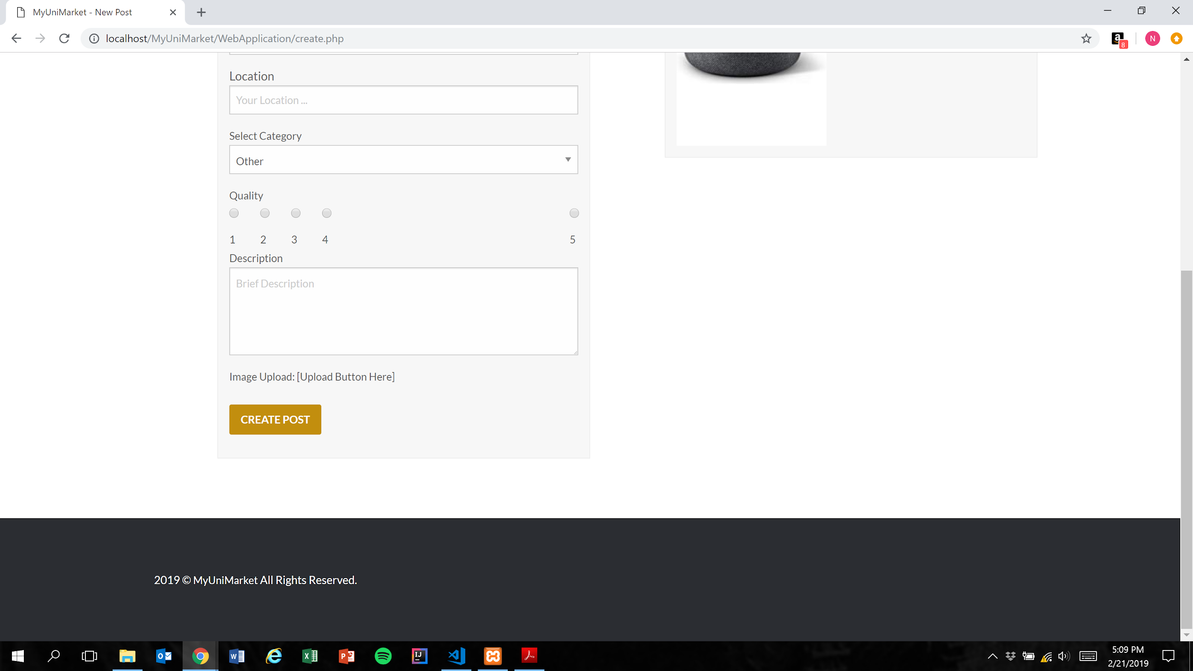

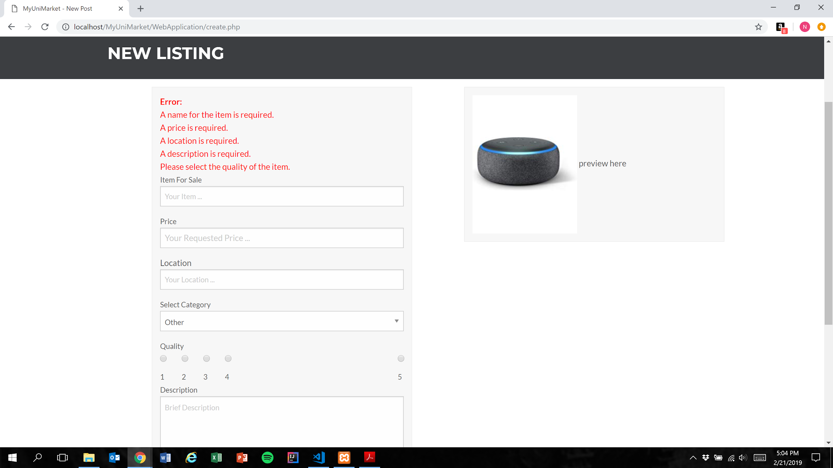

Expected Result: Listing is not added to the database and user is shown error messages for each missing category

Test Result: **PASSED**

**Test 2: Given that the user have not filled out all required fields in the listing, if they attempt to post their listing, then the listing is not added to the database and they are prompted to fill the remaining required fields**

Purpose: To meet acceptance criteria that improperly formatted listings are not added to the database

Steps:

1. User inputs text into the “Item For Sale” field only

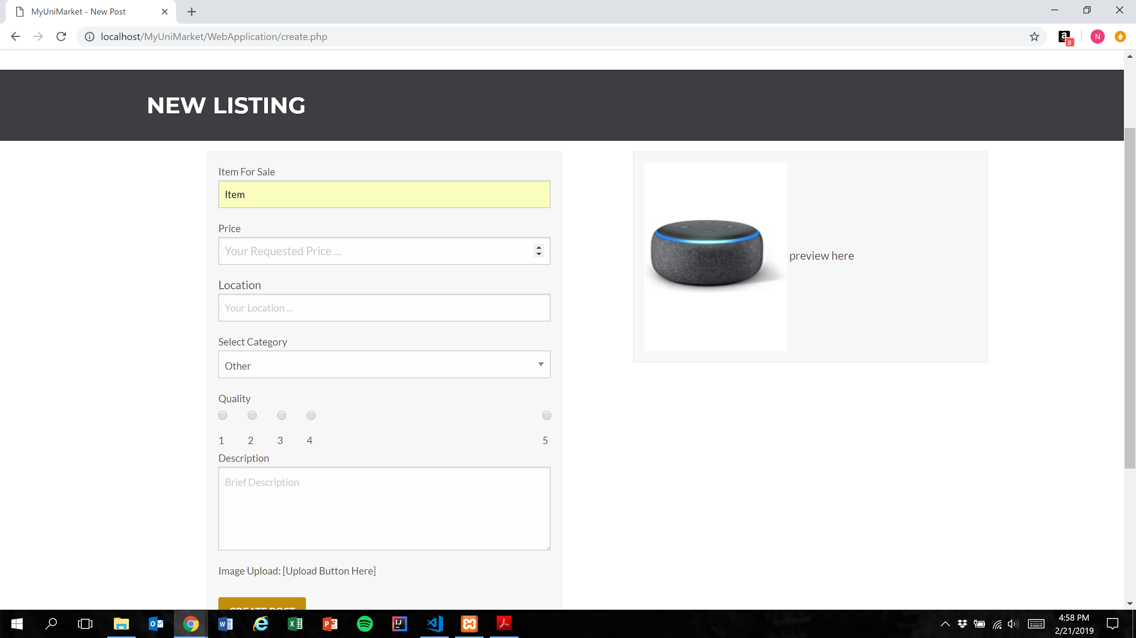

1. User presses the create post button (Figure 1)

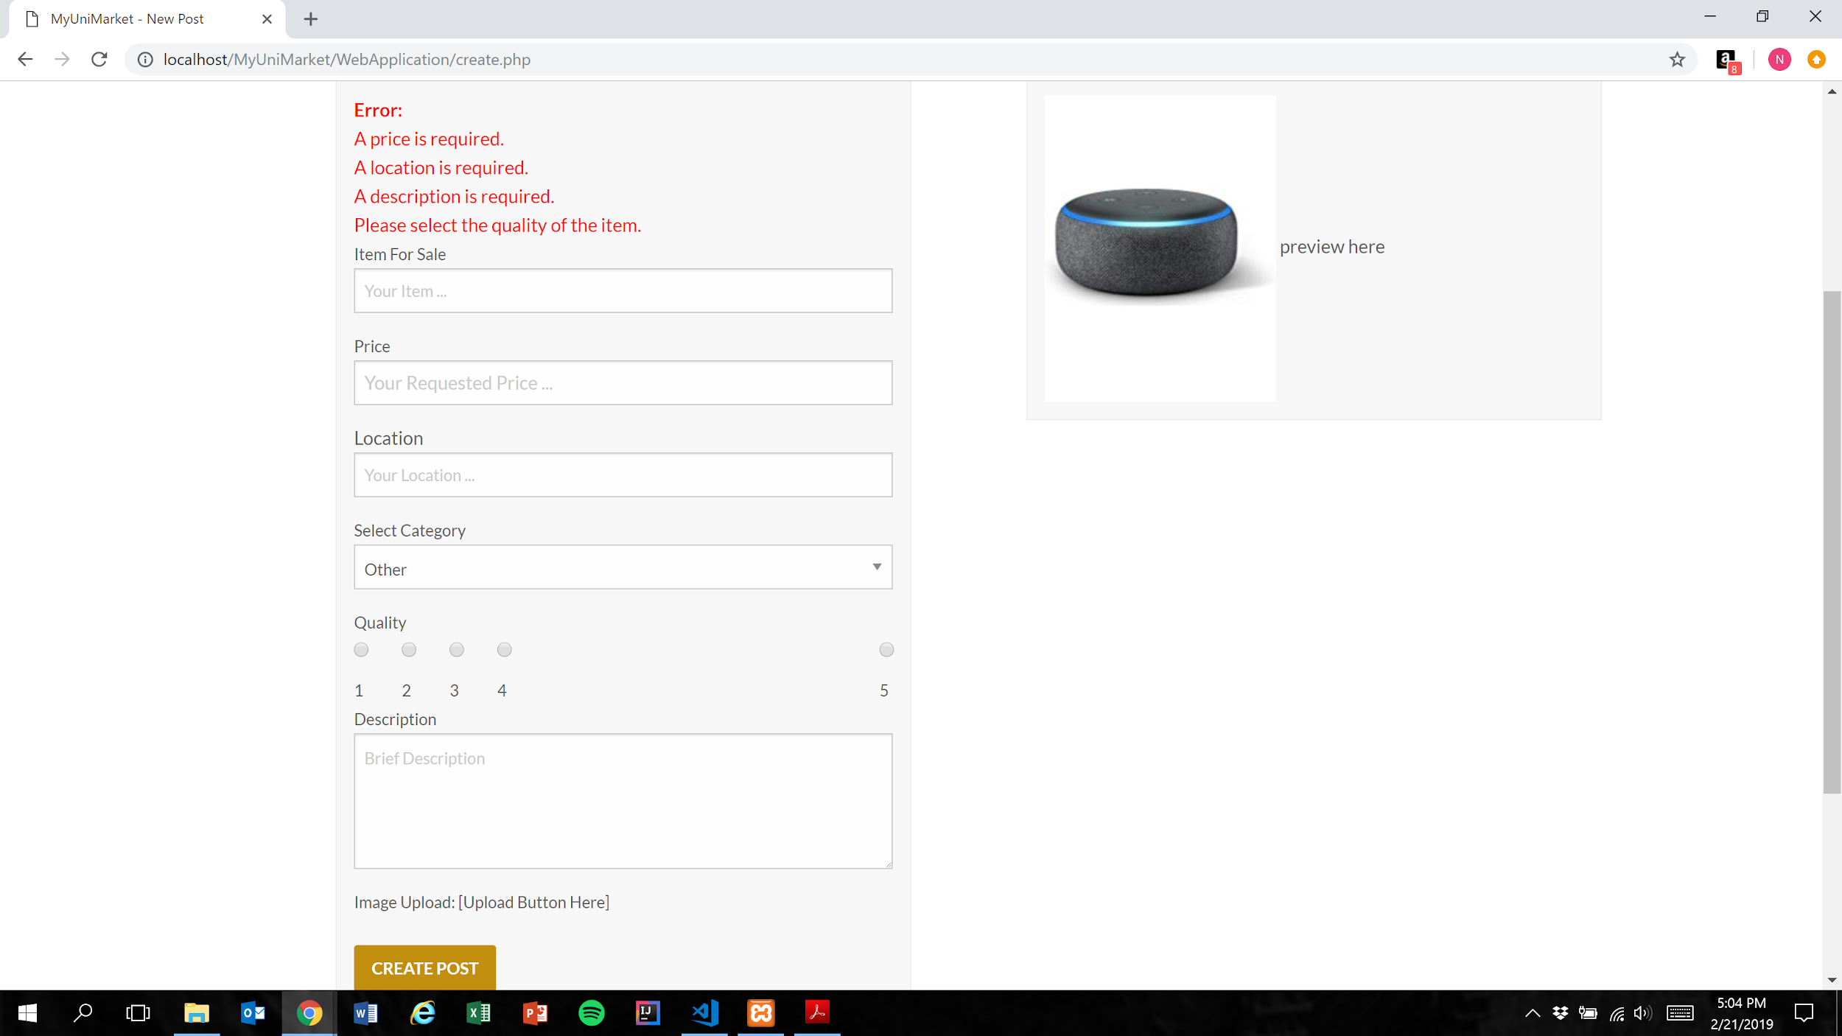

Expected Result: Listing is not added to the database and user is shown error messages for each remaining missing category

Test Result: **PASSED**

**Test 3: Given that the user have not filled out all required fields in the listing, if they attempt to post their listing, then the listing is not added to the database and they are prompted to fill the remaining required fields**

Purpose: To meet acceptance criteria that improperly formatted listings are not added to the database

Steps:

1. User inputs text into the “Item For Sale” and “Price” fields only

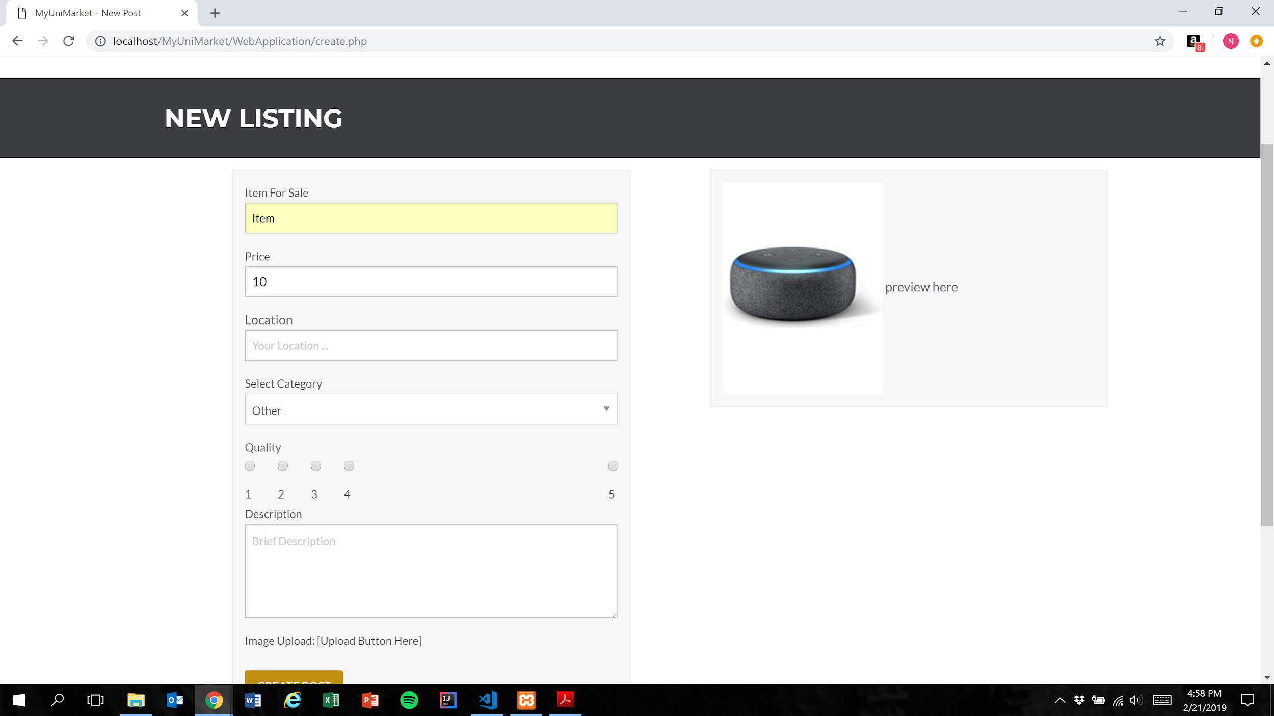

1. User presses the create post button (Figure 1)

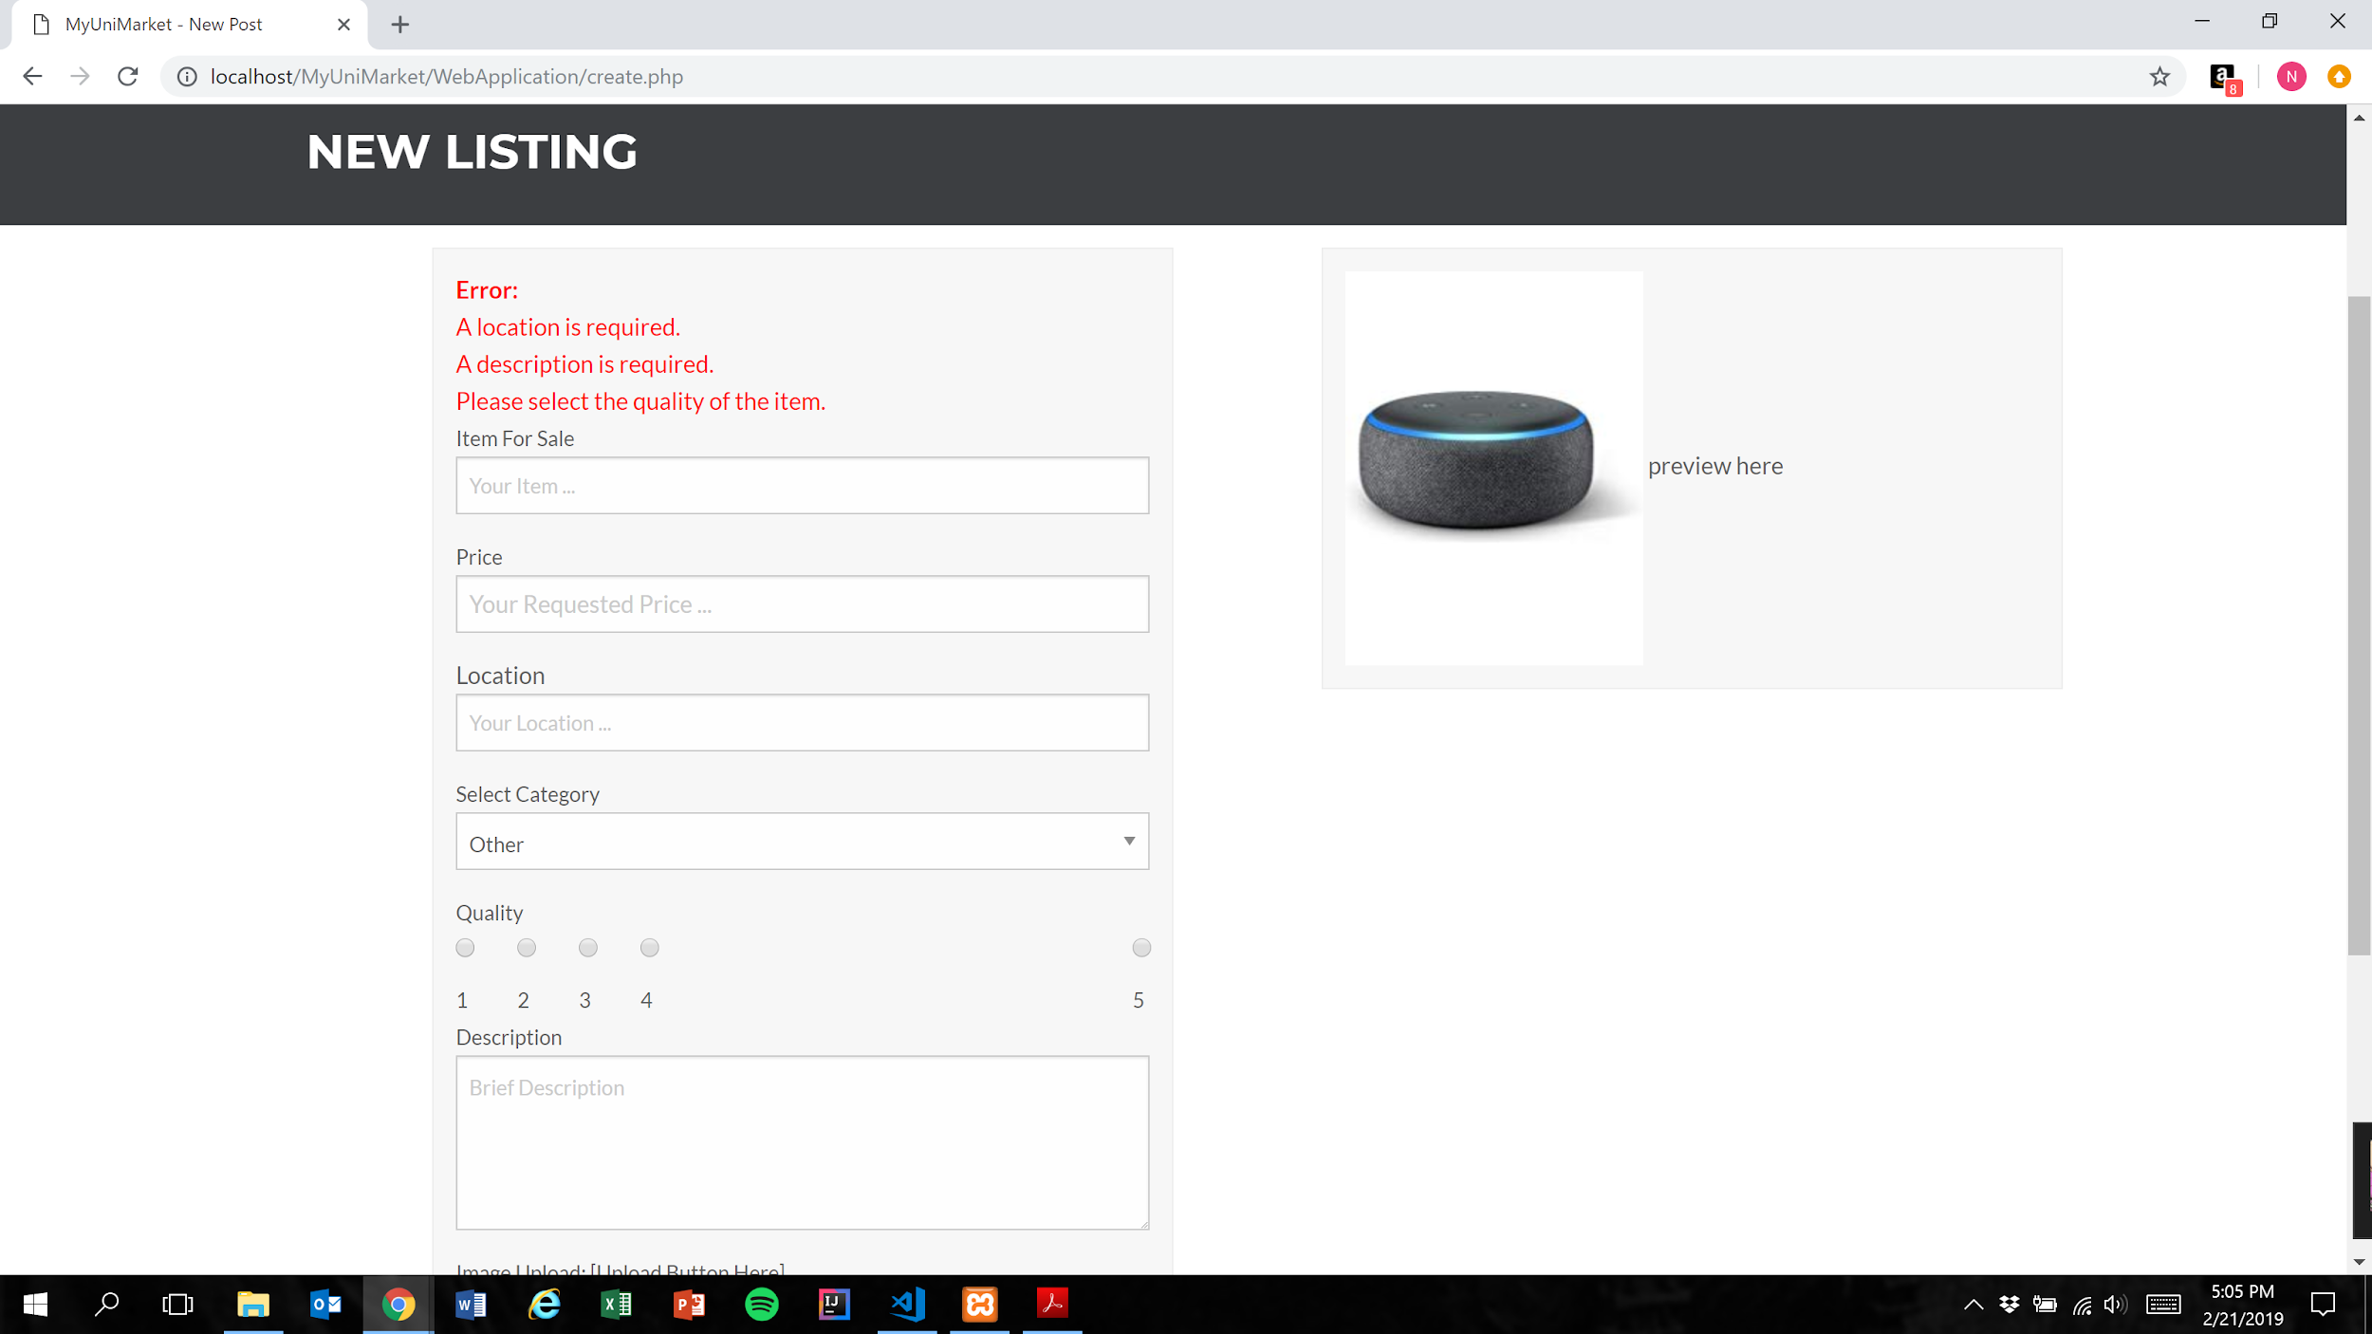

Expected Result: Listing is not added to the database and user is shown error messages for each remaining missing category

**NOTE:** In price field, user is only able to type number characters and the “.” character. This functionality cannot be shown via screenshots but is important to mention

Test Result: **PASSED**

**Test 4: Given that the user have not filled out all required fields in the listing, if they attempt to post their listing, then the listing is not added to the database and they are prompted to fill the remaining required fields**

Purpose: To meet acceptance criteria that improperly formatted listings are not added to the database

Steps:

1. User inputs text into the “Item For Sale”, “Price”, and “Location” fields only

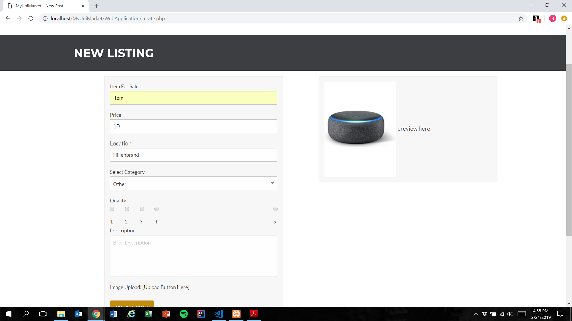

1. User presses the create post button (Figure 1)

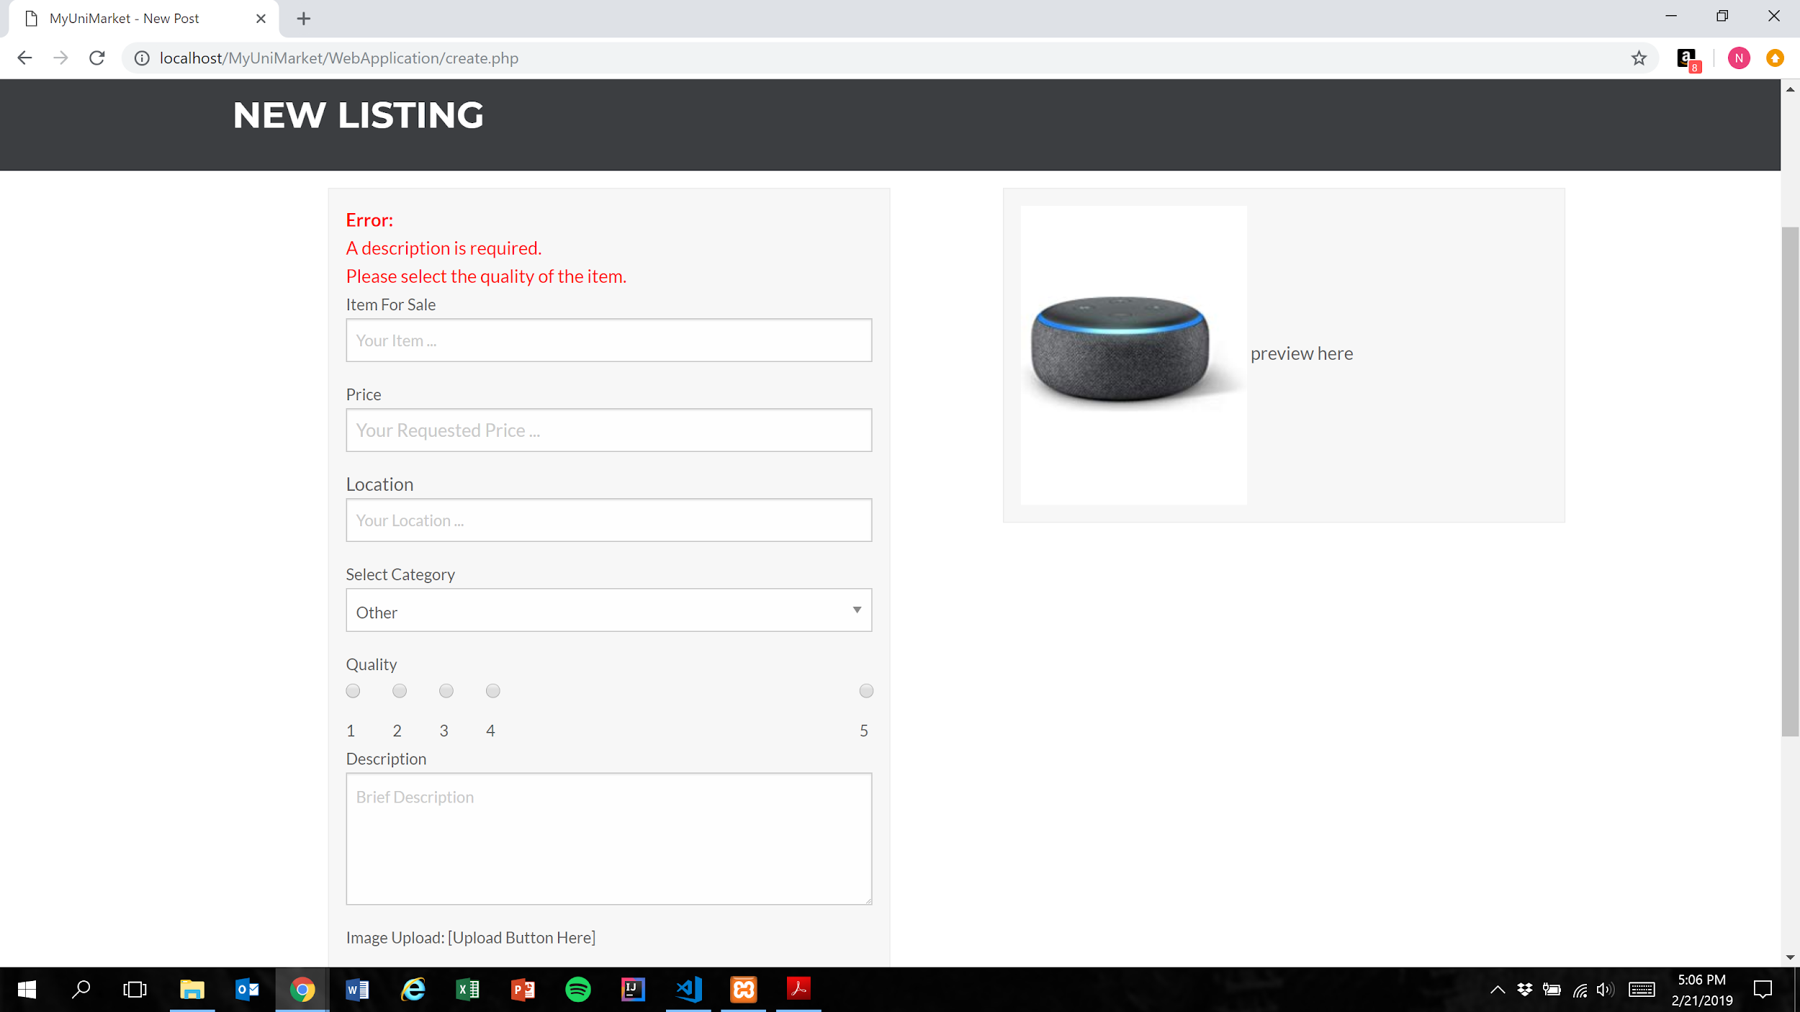

Expected Result: Listing is not added to the database and user is shown error messages for each remaining missing category

Test Result: **PASSED**

**Test 4: Given that the user have not filled out all required fields in the listing, if they attempt to post their listing, then the listing is not added to the database and they are prompted to fill the remaining required fields**

Purpose: To meet acceptance criteria that improperly formatted listings are not added to the database

Steps:

1. User inputs text into the “Item For Sale”, “Price”, and “Location” fields and selects an option for the “Quality” field only

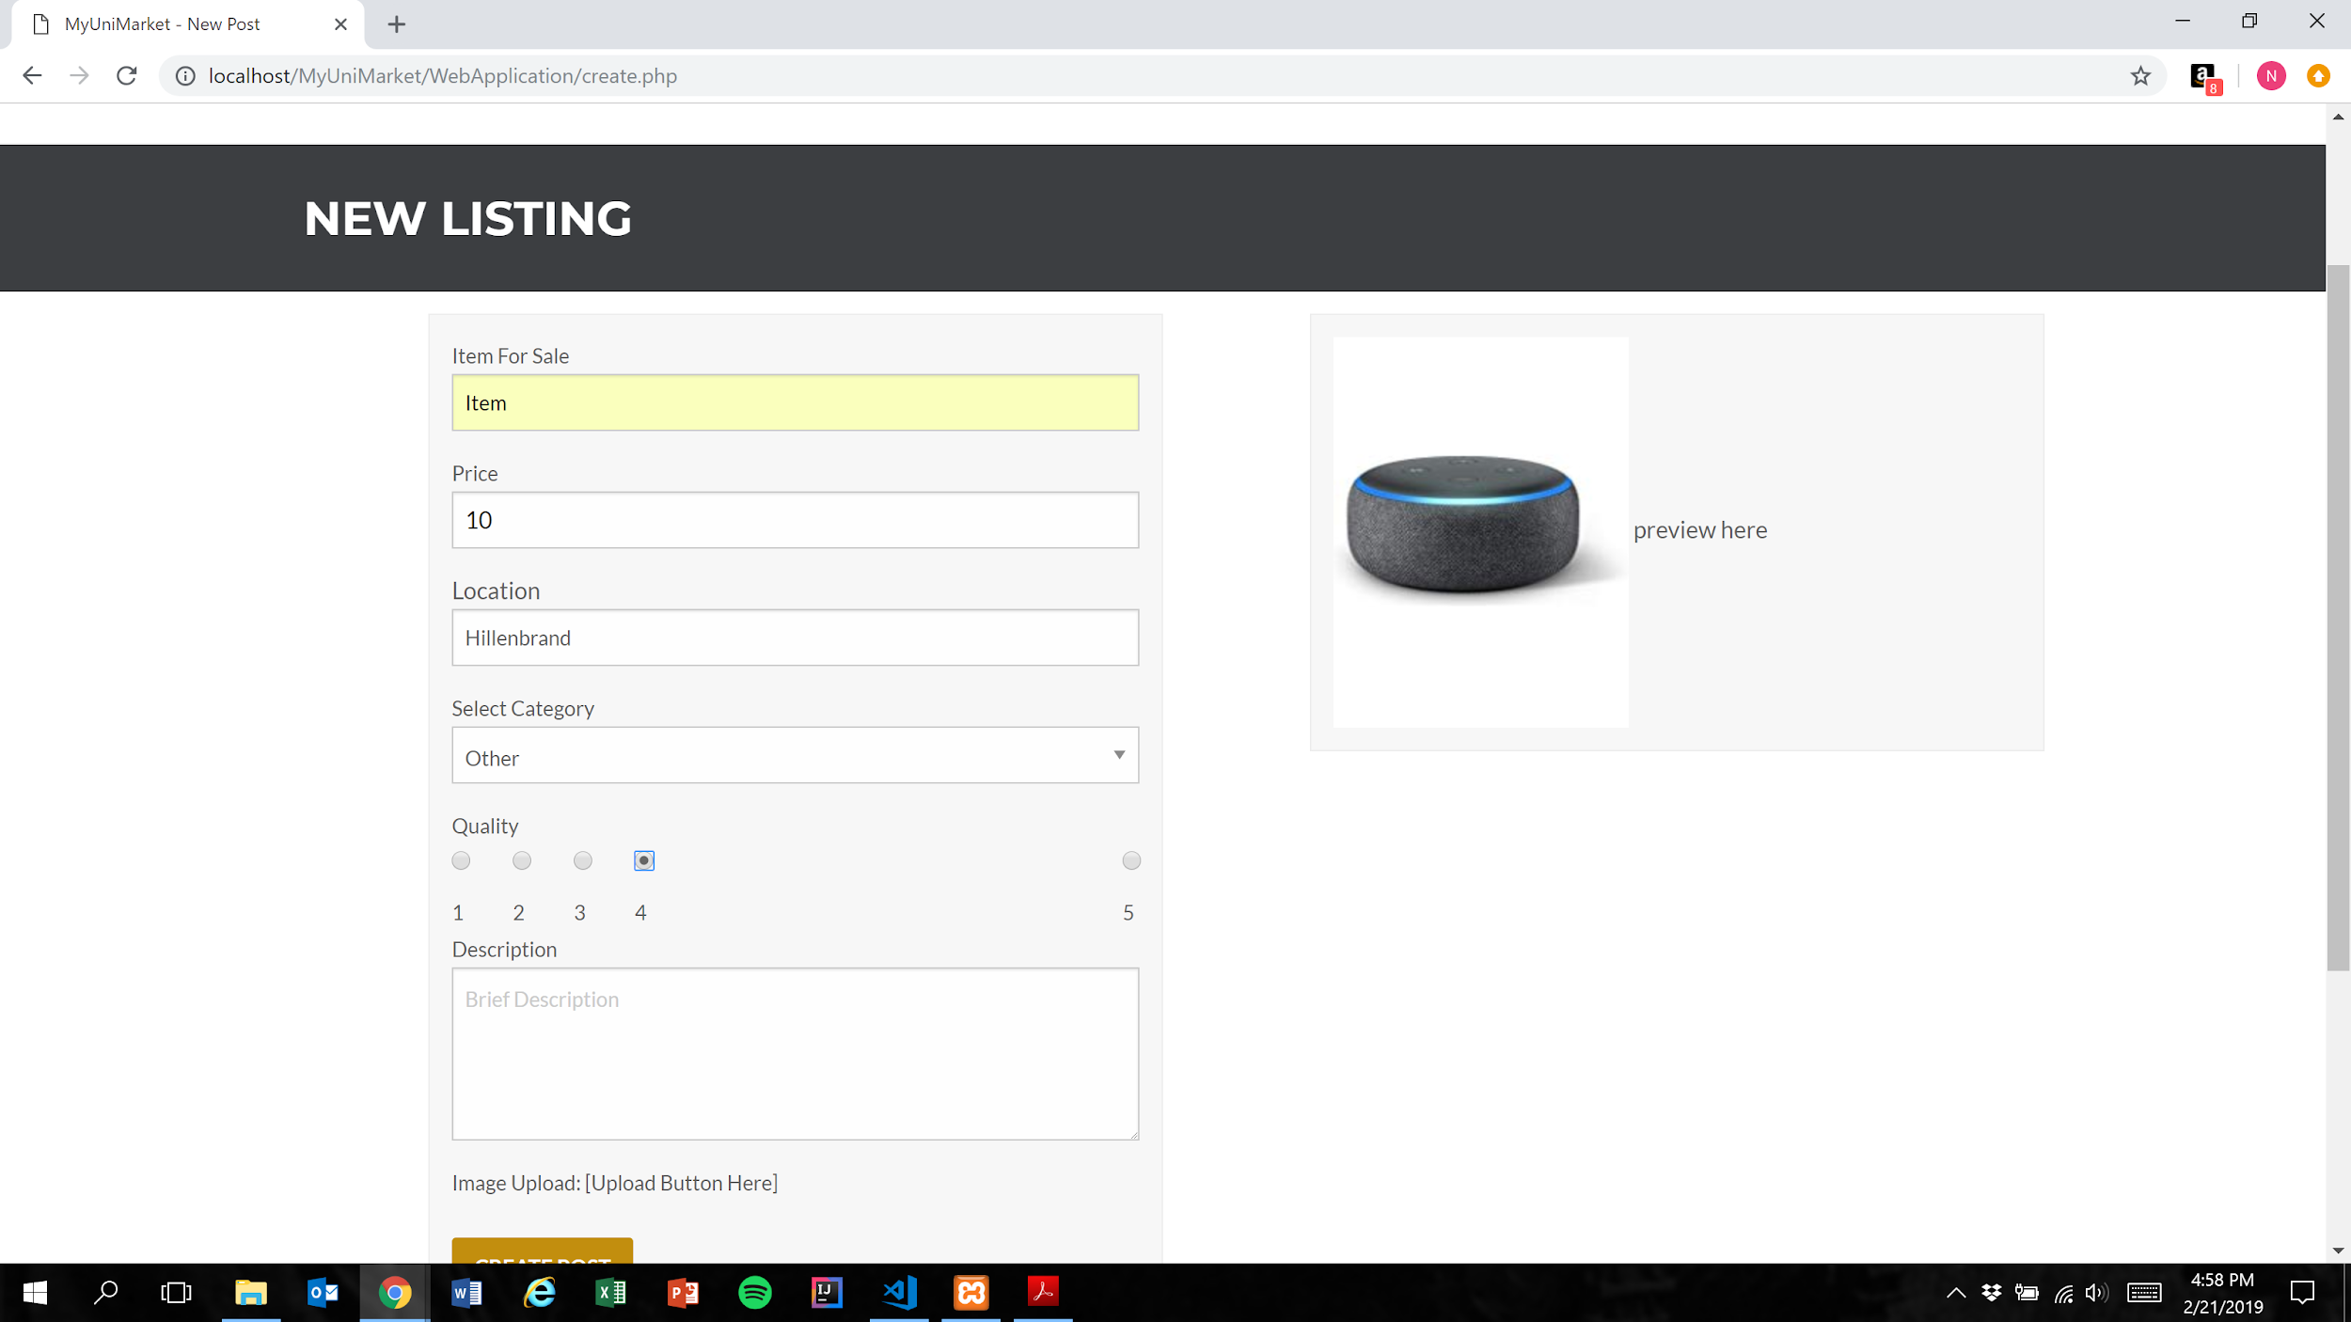

1. User presses the create post button (Figure 1)

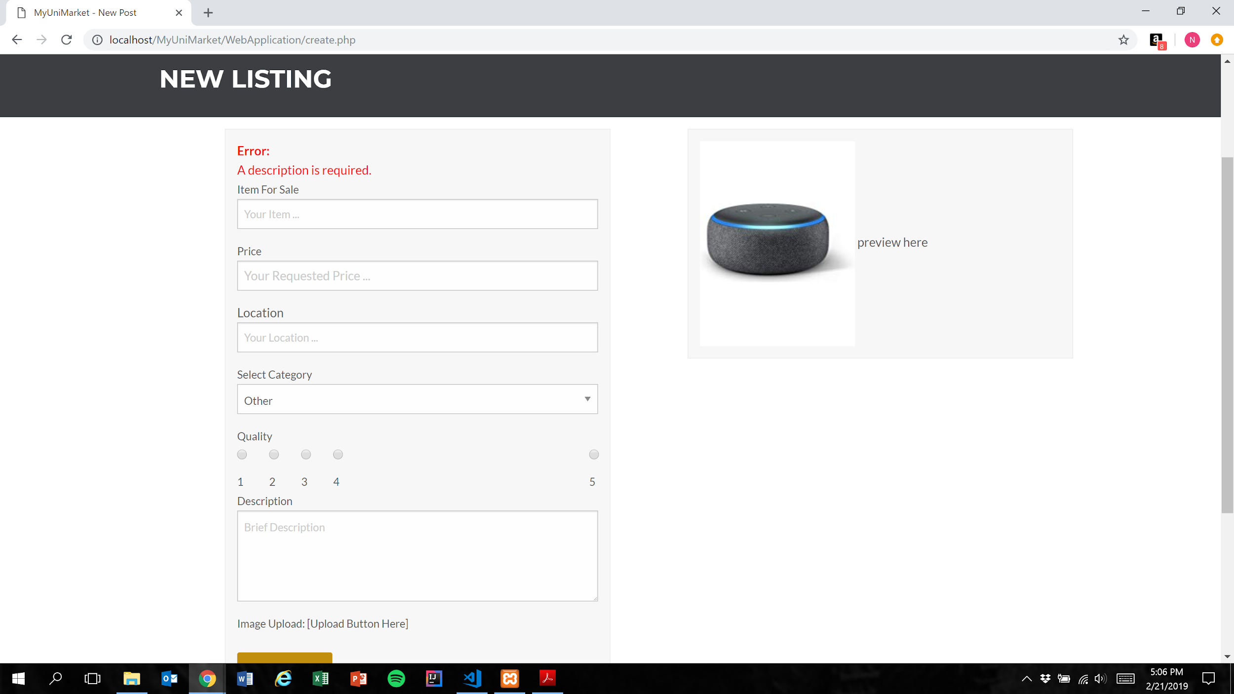

Expected Result: Listing is not added to the database and user is shown error messages for each remaining missing category

Test Result: **PASSED**

**Test 5: Given that the user has filled out all required fields in the listing, if they attempt to post their listing, then the listing is added to the database**

Purpose: To meet acceptance criteria that properly formatted listings are added to the database

Steps:

1. User inputs text into the “Item For Sale”, “Price”, “Location”, and “Description” fields and selects an option for the “Quality” field

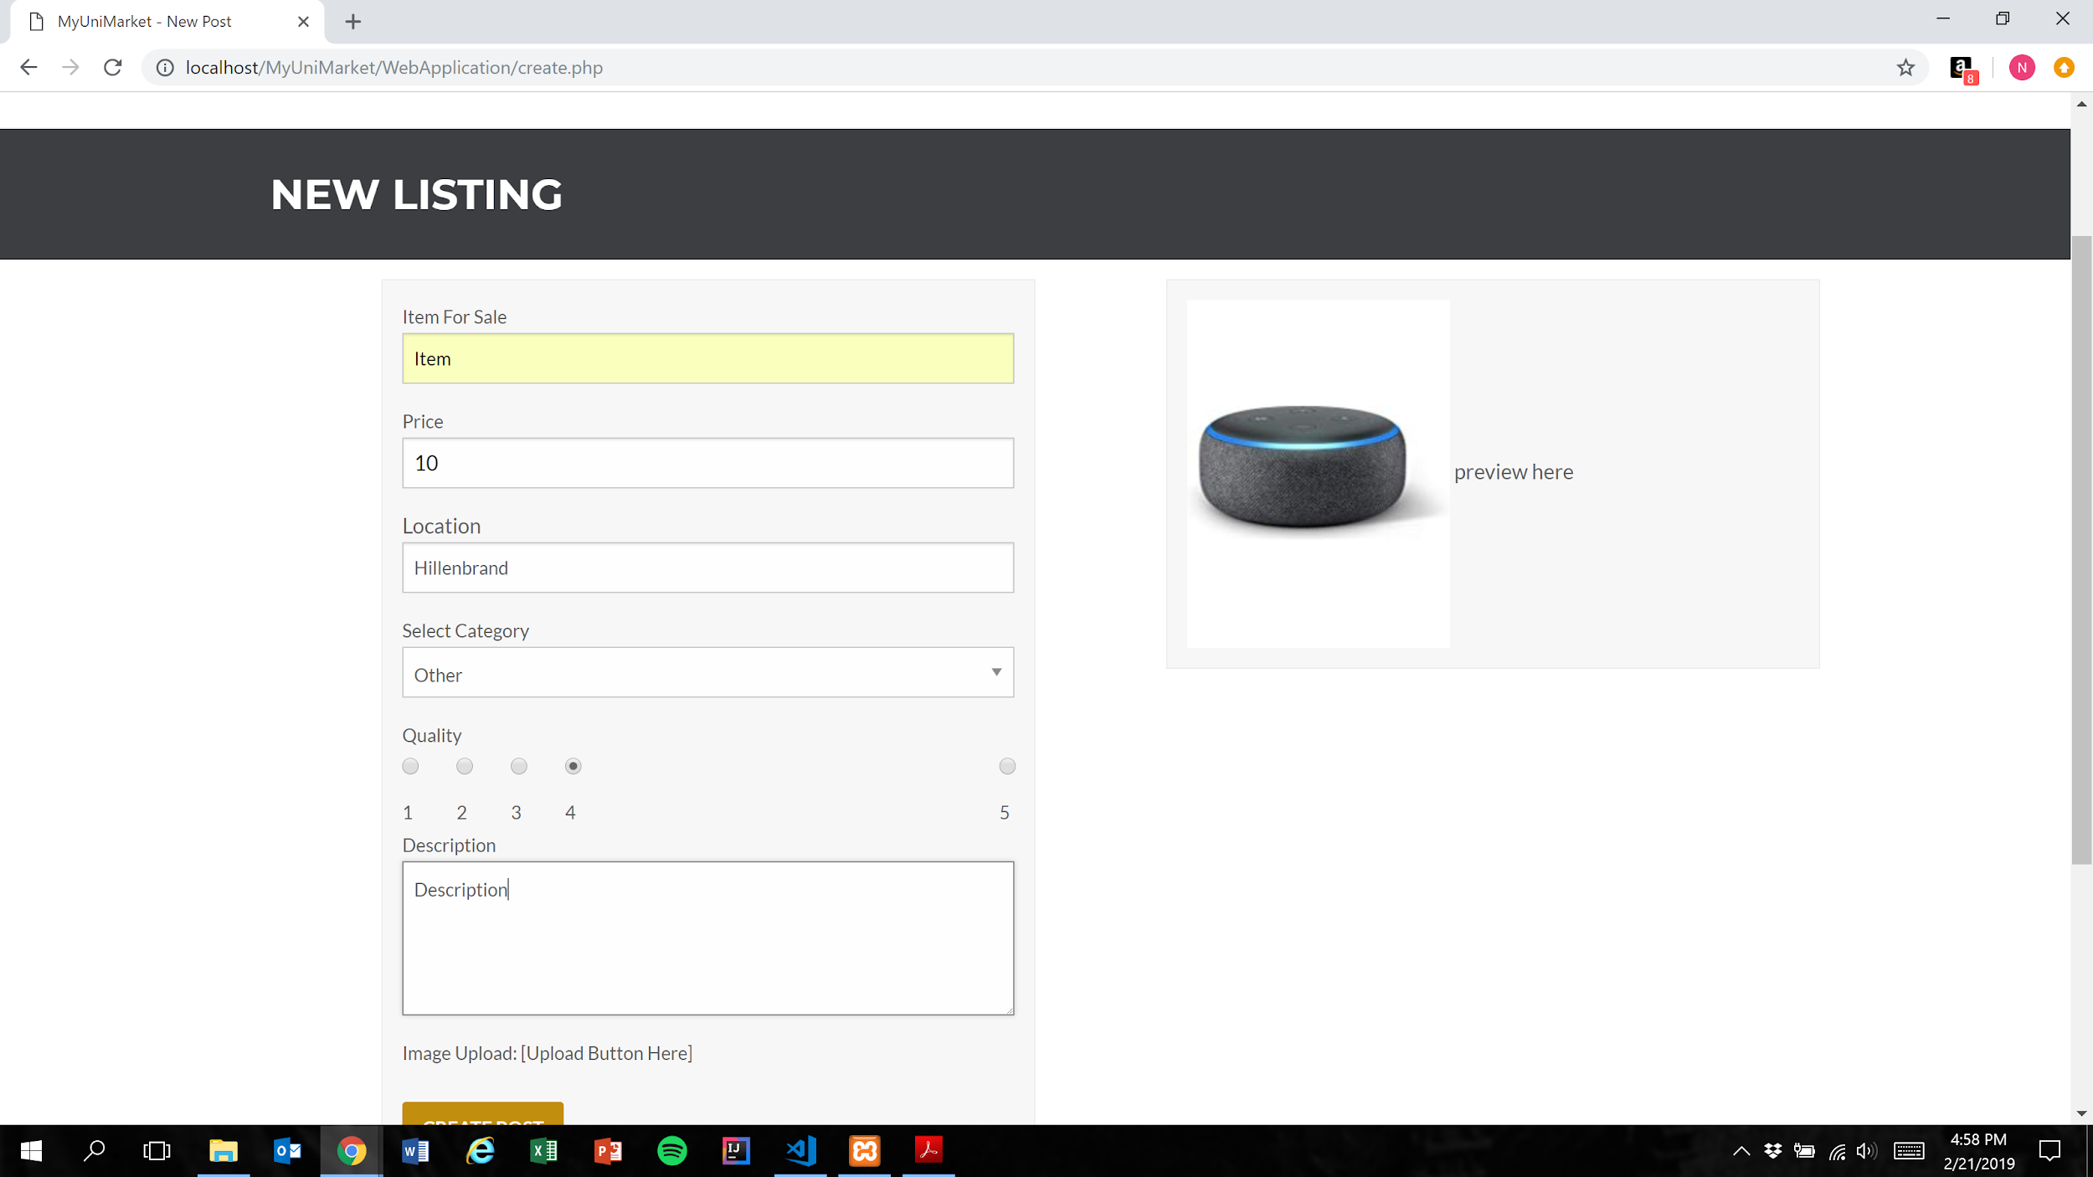

1. User presses the create post button (Figure 1)

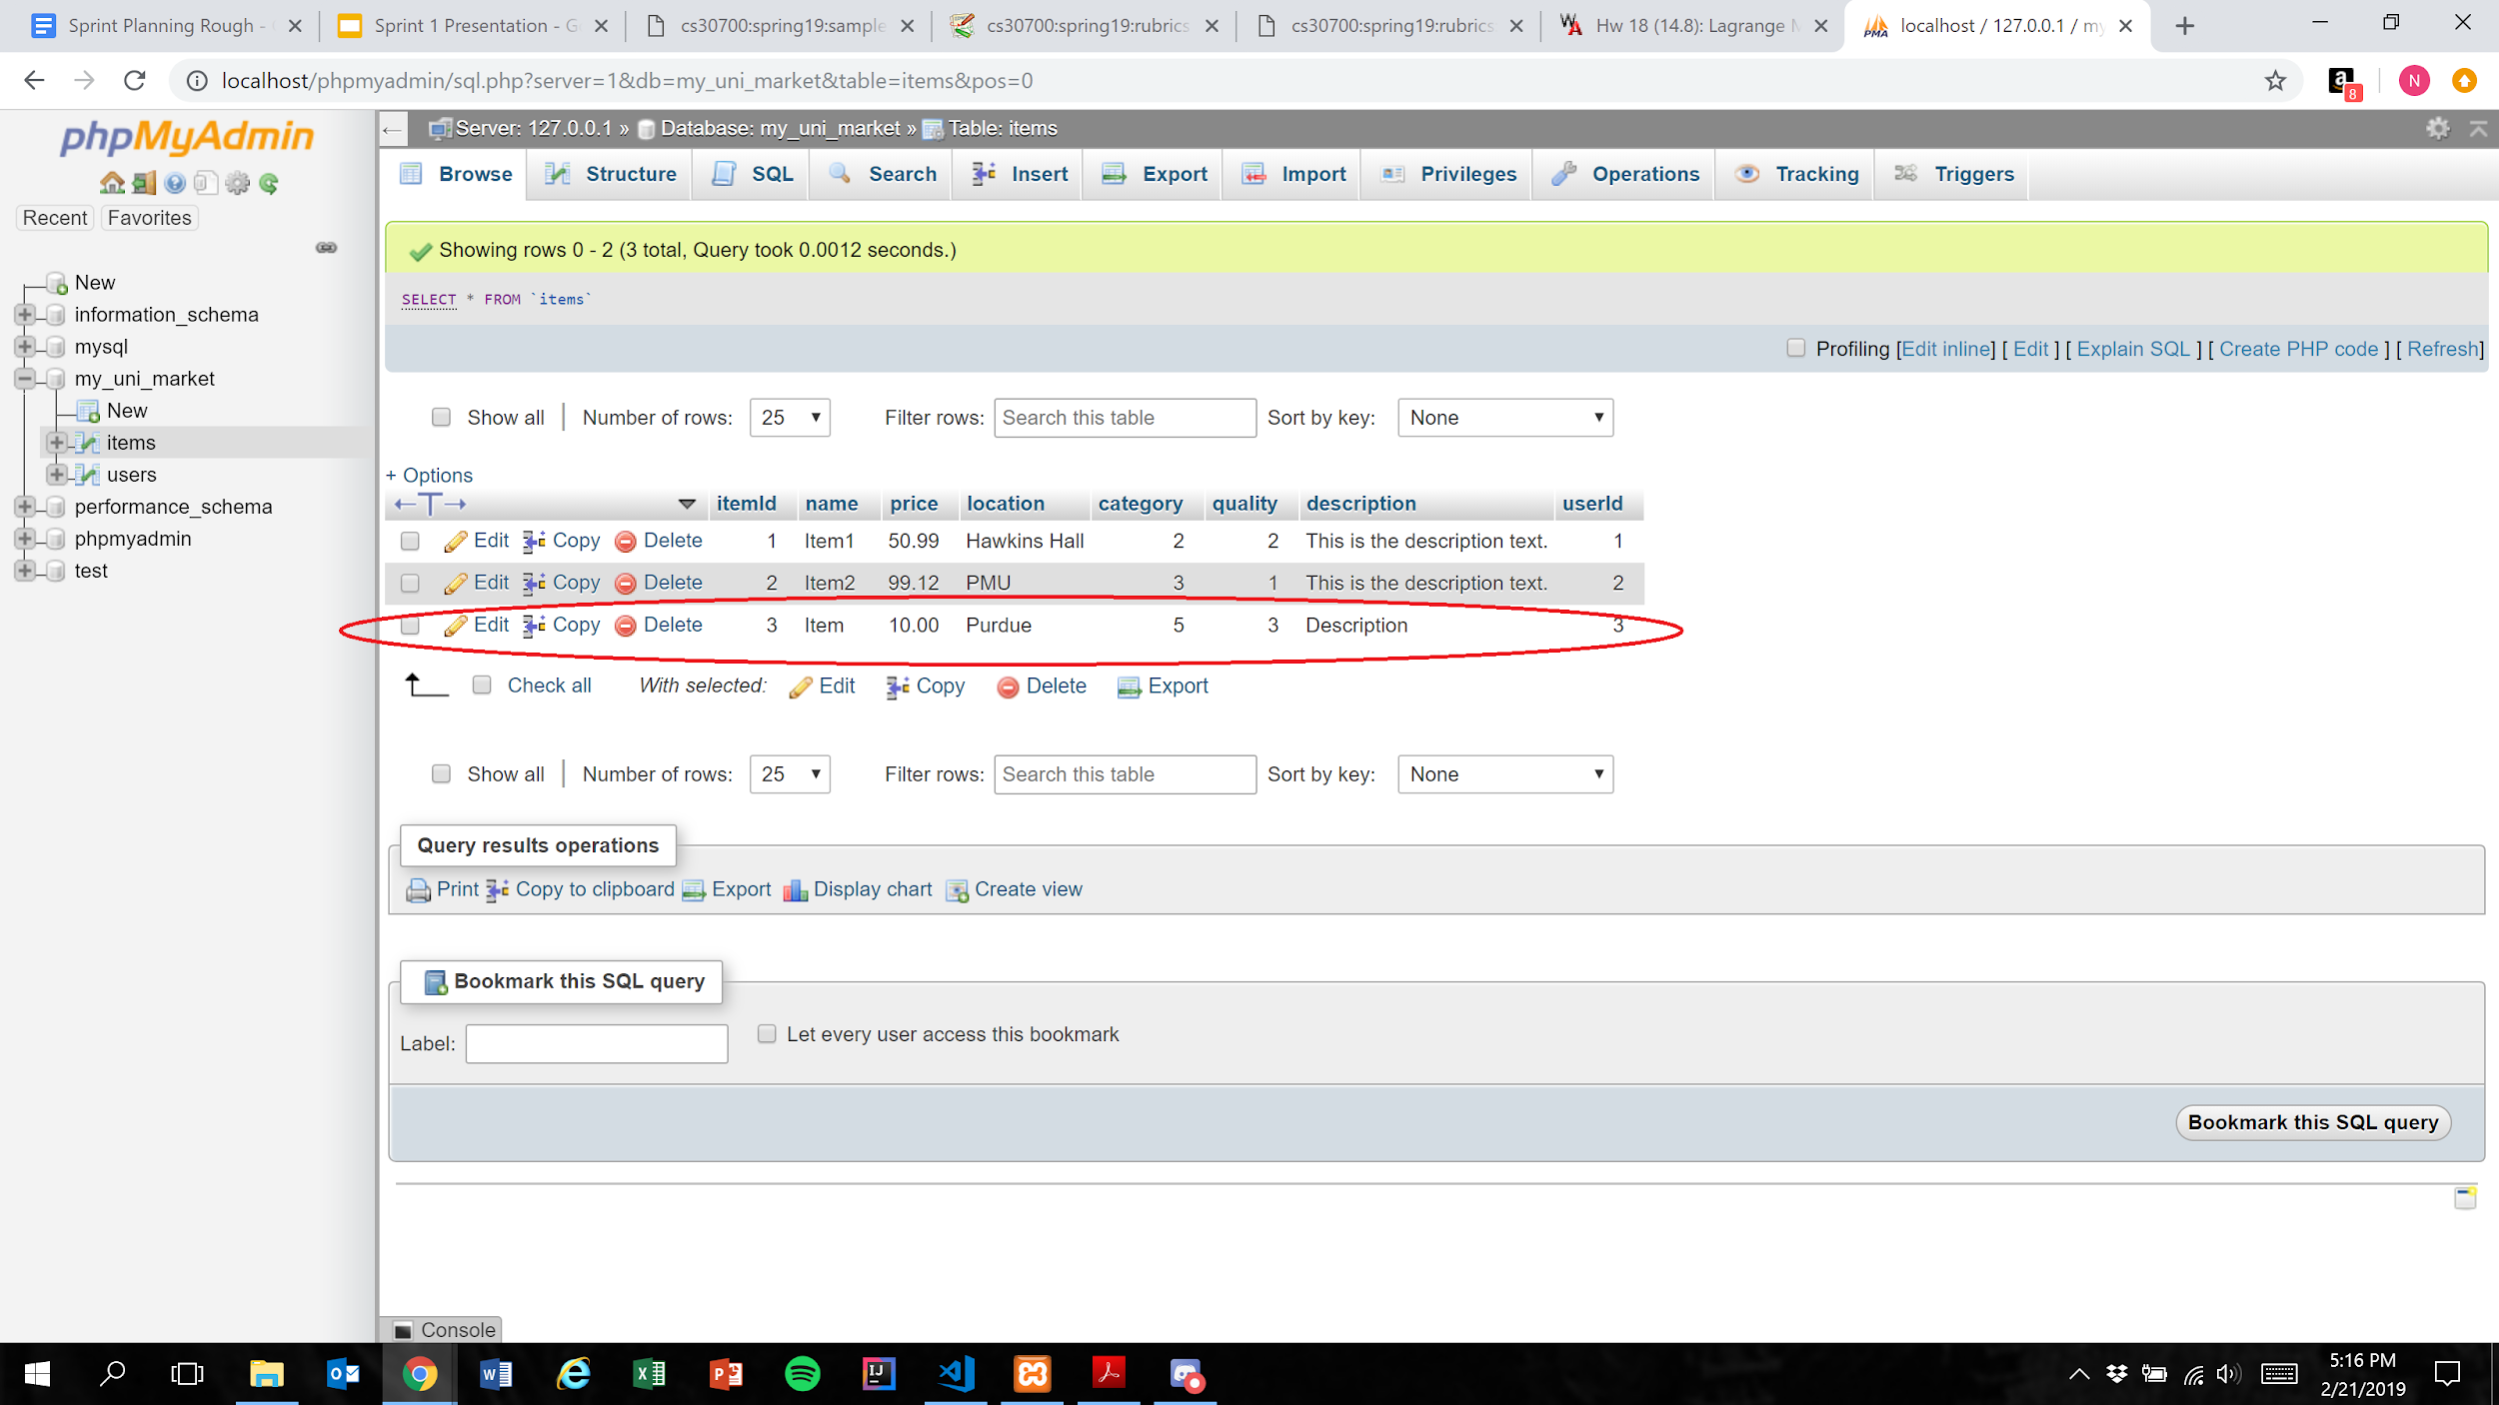

Expected Result: Listing is added to the database

**NOTE:** Marketplace functionality was not implemented as part of this sprint, so the user is not notified when they successfully post a listing. Additionally, the quality integer in the database is 1 less than the quality selected by the user. This is expected behavior.

Test Result: **PASSED**